



SESSION 15: R FOR BUSINESS ANALYTICS

Assignment 1

Table of Contents

1. Introduction .......................................................................................................................................... 3

2. Objective ............................................................................................................................................... 3

3. Prerequisites ......................................................................................................................................... 3

4. Associated Data Files ............................................................................................................................ 3

5. Problem Statement ............................................................................................................................... 3

6. Expected Output ................................................................................................................................... 3

7. Approximate Time to Complete Task ................................................................................................... 3

Data Analytics

1. Introduction

This assignment will help you understand the concepts learnt in the session.

2. Objective

To understand the concepts in R.

3. Prerequisites

Not applicable.

4. Associated Data Files

N/A

5. Problem Statement

Here is a table with 6 rows and 3 Columns :

X Y Z

910 a1 b1 820 a2 b2 730 a3 b3 640 a4 b4

550 a5 b5

460 a6 b6

Put the data in .xlsx, .txt , .csv and read it using R Code.

Solution :- **a) R code for read .csv file. > data1 <- read.csv(file.choose(), header=T)**

**> data1**

**b) R code for read .txt file. > data2 <- read.delim(file.choose(), header=T)**

**> data2**

**c) R code for read .xlsx file. > data3 = read.xlsx(file.choose(), sheetIndex = 1)**

**> data3**

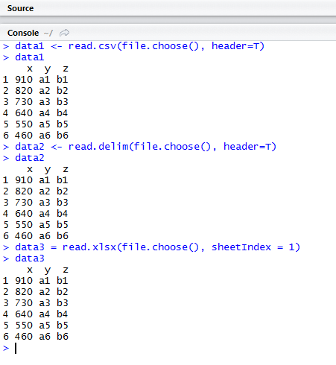

6. Expected Output

N/A

7. Approximate Time to Complete Task